Methodology
The Pharmacy Sales & Stock Management System is developed with the Systems Development Life Cycle (SDLC) using a sequential (waterfall) approach. Each phase is finished and reviewed before the next one starts.

Phase | Main activities | Deliverables
Planning | Prepare the system request, study the technical, economic and operational feasibility, and build the project schedule. | System Request, Feasibility Study, PERT chart, Gantt chart
Analysis | Interview pharmacists and staff, collect questionnaires, and model the sales and stock processes. | Data Flow Diagrams, data stores, process specifications, data dictionary
Design | Design the database and the screens for sales, stock, expiry alerts and reports, then review a prototype. | ER diagram, normalized database, UI design, approved prototype
Implementation | Code the system, test it, enter the initial stock data, then deploy and train the staff. | Working system, test results, trained users
Why this methodology?
- The requirements are clear from the start: sales, stock levels, expiry tracking and reports.
- The project has a fixed deadline, and each phase produces a document that can be checked.
- Data security and patient-data rules must be planned in the design phase, before coding starts.
Time Estimation
 | Planning | Analysis | Design | Implementation
Standard percentages | 15% | 20% | 35% | 30%
Estimated time based on planning time | Actual: 11 days | 15 days | 26 days | 22 days
Total estimated duration: 74 days (08/11/2026 – 20/01/2027).
Estimated time = actual planning time ÷ 15% × the percentage of each phase. All durations are calendar days.
Case Study
Background
A community pharmacy sells prescription and over-the-counter medicines to customers every day. Sales, stock levels and expiry dates are recorded on paper registers and simple spreadsheets.
Problem
- Billing is manual, so customers wait in long queues at checkout.
- Staff cannot see stock in real time, so some medicines run out while others expire unsold.
- Stock leakage goes unnoticed, and there is no purchase or prescription history for customers.
- Management and financial reports are prepared by hand, which is slow and error-prone.
Proposed Solution
A Pharmacy Sales & Stock Management System with:
- Point of Sale with barcode scanning for fast, accurate billing.
- Real-time online inventory for all branches, with automatic expiry-date tracking and low-stock alerts.
- Customer purchase history and prescription records.
- Management and financial reports, data encryption, and offline sync during network outages.
Expected Results
- 5% to 10% increase in pharmacy sales revenue.
- 20% reduction in inventory holding and expired-stock costs.
- 40% faster checkout time per customer.
- $150,000+ estimated annual operational cost savings.
PERT Chart
Part 1: Planning and Analysis
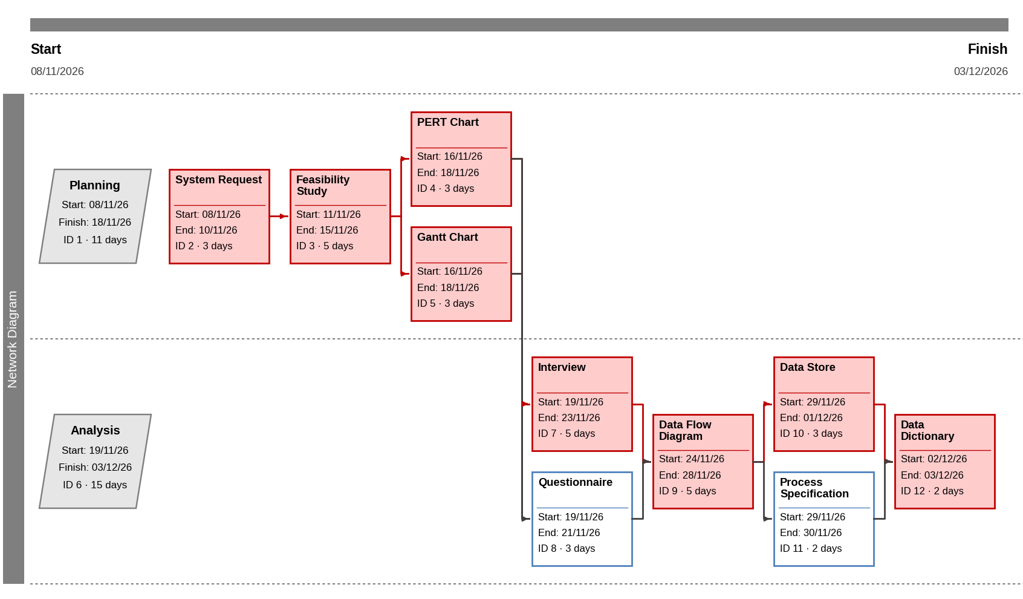
Part 2: Design and Implementation
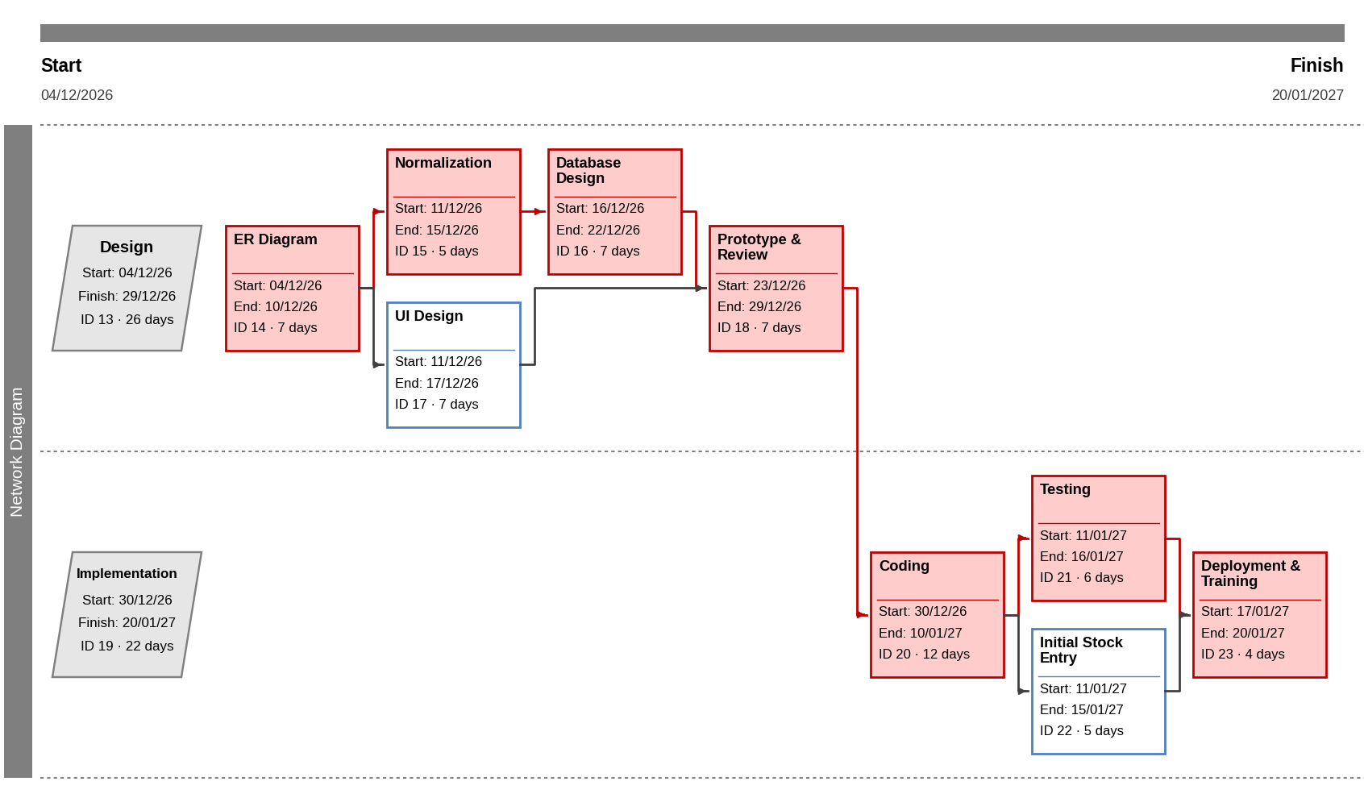
Red boxes are on the critical path; white boxes have slack. Durations are calendar days.
Gantt Chart
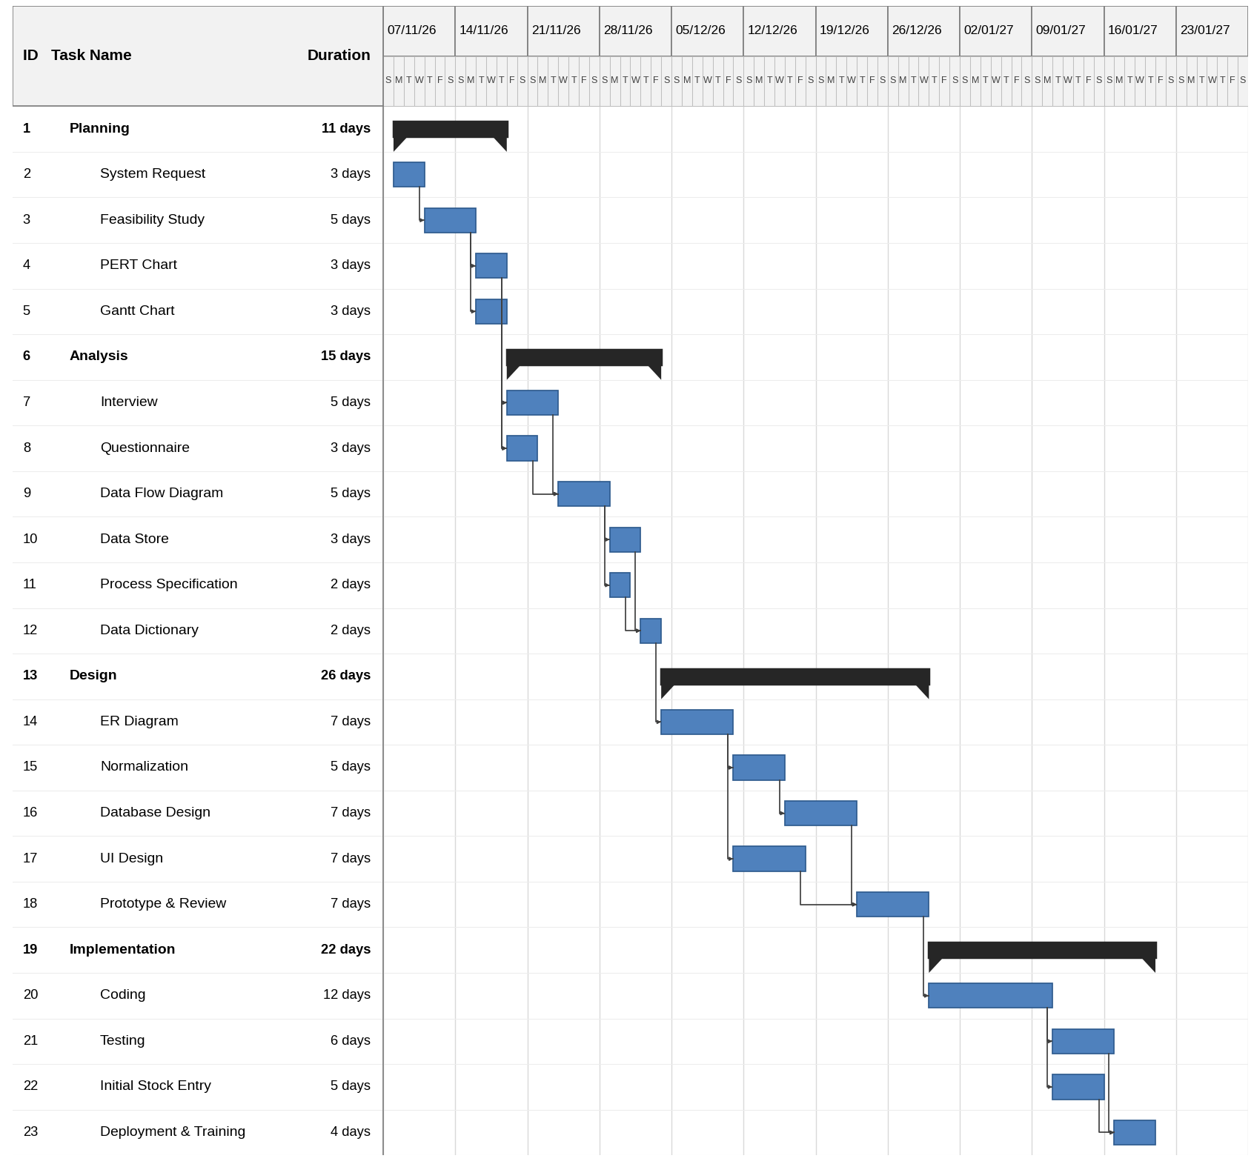
Project start 08/11/2026, finish 20/01/2027 (74 days).

